Variance & Standard Deviation in R

Problem Statement
Variance quantifies spread but is expressed in squared units, making it hard to interpret next to the mean. Two distributions can share a similar centre yet differ dramatically in dispersion (teacher grades; NBA vs OkCupid heights). We need a scale-matched measure (standard deviation) and a way to say how unusual any single observation is (z-score / empirical rule).

Solution Strategy
1. Recap population variance from first principles. 2. Take the square root to obtain standard deviation (original units). 3. Contrast R’s sample sd()/var() with population formulae. 4. Compute z-scores for LeBron (80 in) and Earl Boykins (65 in) against both height distributions. 5. Verify the empirical rule (~68/95/99.7 %). 6. Supply alternates, practice, Monte-Carlo coverage simulation, and audience-adapted messaging.

Solution
Teachers — T1: μ≈84.5, σ≈2.1 (tight); T2: μ≈84.3, σ≈9.0 (wide). Heights — NBA: μ≈77.9, sd≈3.6; OkCupid: μ≈69.2, sd≈4.1. LeBron z: +0.58 (NBA) vs +2.62 (OkC). Boykins z: −3.63 (NBA) vs −1.02 (OkC). Empirical coverage on data ≈ 0.66–0.68 / 0.95 / 0.99; simulation recovers 0.68 / 0.96 / 1.00.
Height distributions:
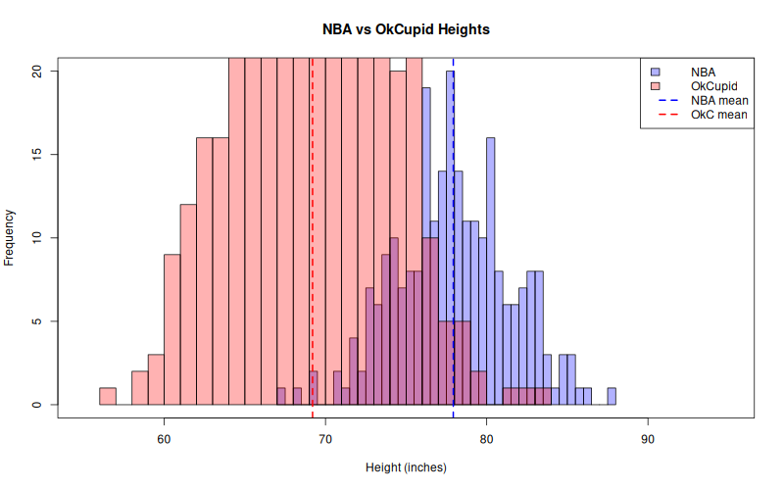
Monte-Carlo ±1 SD coverage:
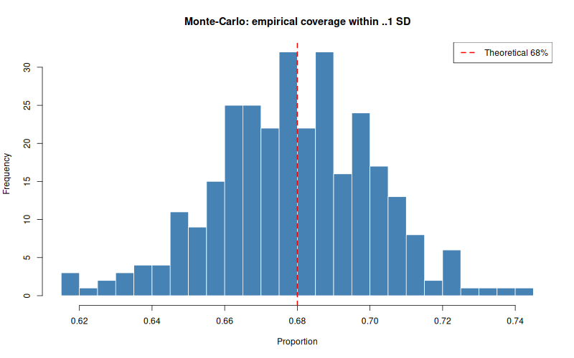

Key Takeaways
• Variance is in squared units; SD restores the original units of the data.
• z = (x − μ) / σ measures how many SDs a point lies from the mean.
• ≈68 % / 95 % / 99.7 % of (near-normal) data fall within ±1 / ±2 / ±3 SD.
• The same absolute difference can be ordinary in a wide distribution and extreme in a narrow one.
• Prefer SD (or z-scores) over raw variance when communicating to any audience; adapt depth for analysts vs non-specialists.

